**MongoDB Assignment – 2**

* **MongoDB -Aggregation Exercises**
* **Atlanta Population**

1. use db.zipcodes.find() to filter results to only the results where city is ATLANTA and state is GA.

* db.zipcodes.find({$and:[{city:"ATLANTA"},{state:"GA"}]}).pretty()

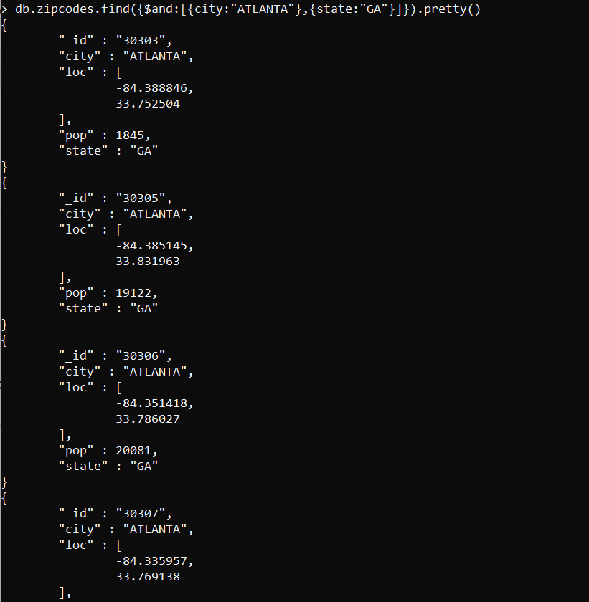

1. use db.zipcodes.aggregate with $match to do the same as above.

* db.zipcodes.aggregate({$match:{$and:[{city:"ATLANTA"},{state:"GA"}]}}).pretty()

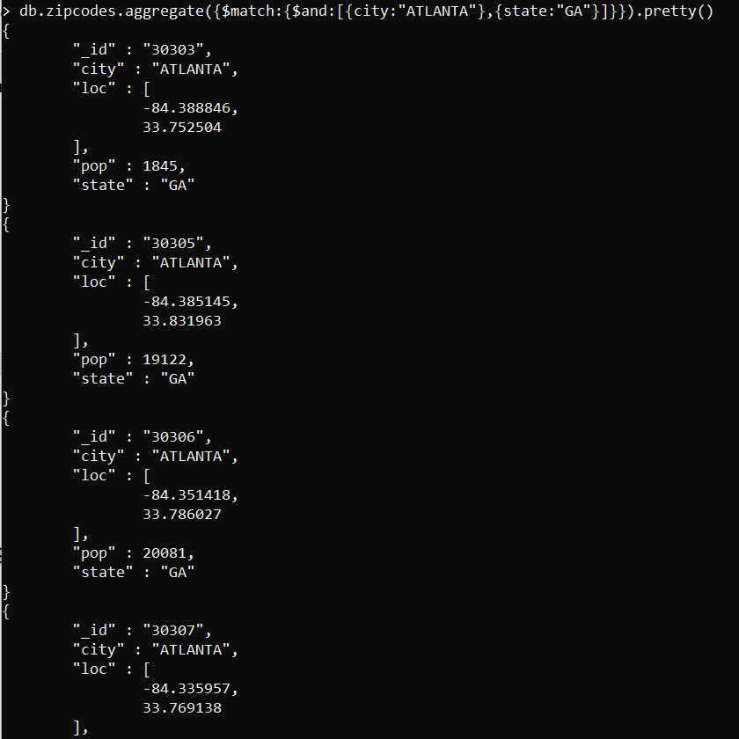

1. use $group to count the number of zip codes in Atlanta.

* db.zipcodes.aggregate([{$match:{city:"ATLANTA"}},{$group:{_id:"$city",count:{$sum:1}}}])

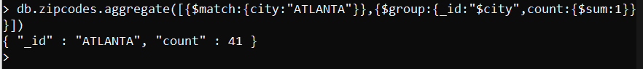

1. use $group to find the total population in Atlanta.

* db.zipcodes.aggregate([{$match:{city:"ATLANTA"}},{$group:{_id:"$city",count:{$sum:"$pop"}}}])

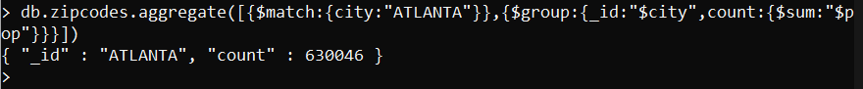

* **Populations By State**

1. use aggregate to calculate the total population for each state

* db.zipcodes.aggregate([{$group:{_id:"$state",count:{$sum:1}}}])

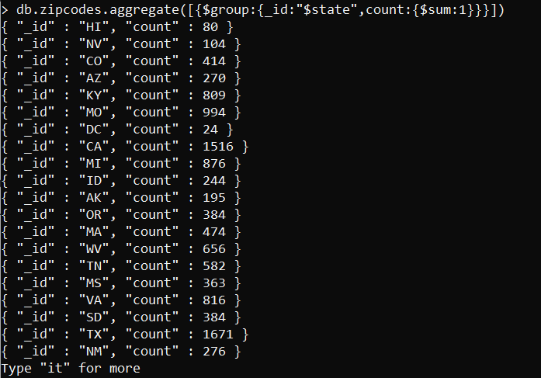

1. sort the results by population, highest first

* db.zipcodes.aggregate([{$group:{_id:"$state",count:{$sum:1}}},{$sort:{count:-1}}])

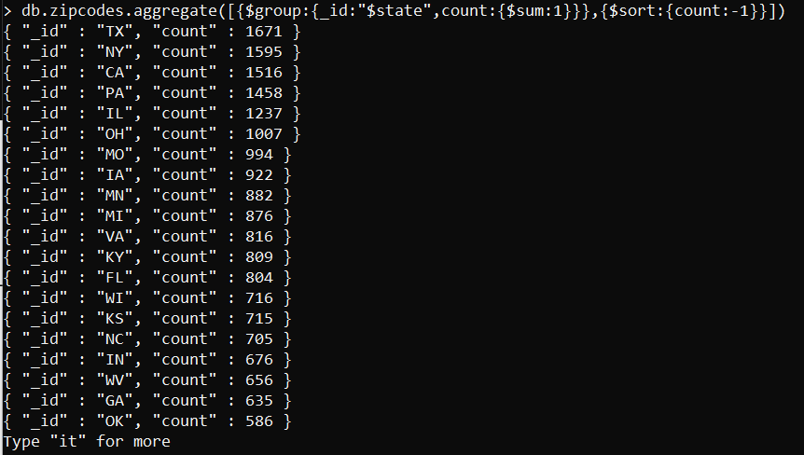

1. limit the results to just the first 3 results. What are the top 3 states in population?

* db.zipcodes.aggregate([{$group:{_id:"$state",count:{$sum:1}}},{$sort:{count:-1}},{$limit:3}])

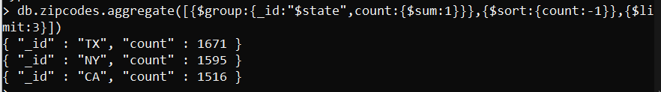

* **Populations by City**

1. use aggregate to calculate the total population for each city (you have to use city/state combination). You can use a combination for the _id of the $group: { city: '$city', state: '$state' }

* db.zipcodes.aggregate([{$group:{_id:{city:"$city",state:"$state"},count:{$sum:1}}}])

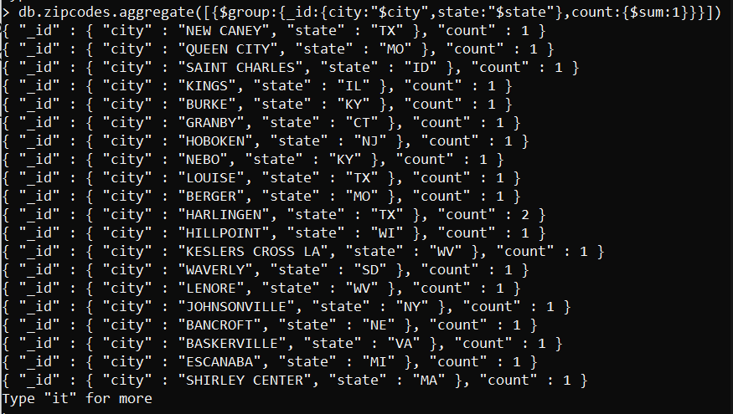

1. sort the results by population, highest first

* db.zipcodes.aggregate([{$group:{_id:{city:"$city",state:"$state"},count:{$sum:1}}},{$sort:{count:-1}}])

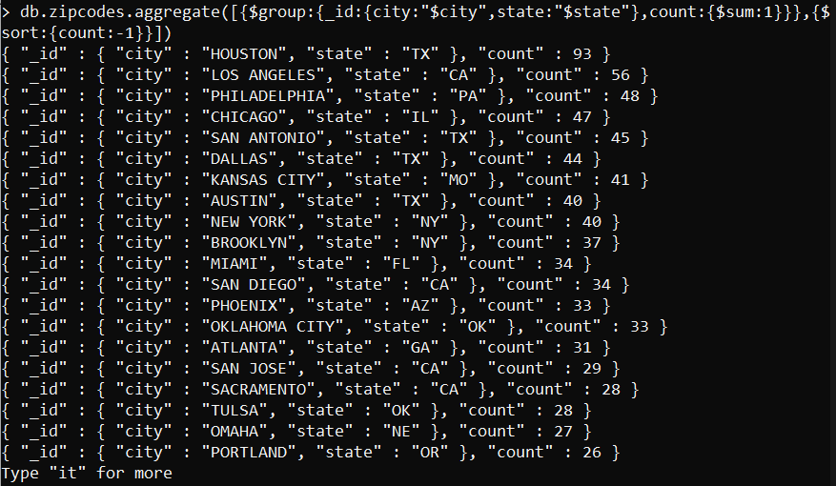

1. limit the results to just the first 3 results. What are the top 3 cities in population?

* db.zipcodes.aggregate([{$group:{_id:{city:"$city",state:"$state"},count:{$sum:1}}},{$sort:{count:-1}},{$limit:3}])

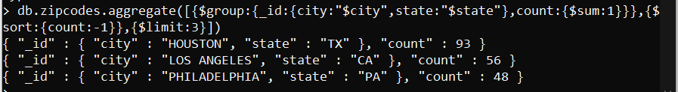

1. What are the top 3 cities in population in Texas?

* db.zipcodes.aggregate([{$match:{state:"TX"}},{$group:{_id:{city:"$city",state:"$state"},count:{$sum:1}}},{$sort:{count:-1}},{$limit:3}])

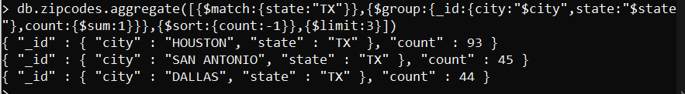

* **Bonus**

1. Write a query to get the average city population for each state.

* db.zipcodes.aggregate([{$group:{_id:"$state",avg:{$avg:"$pop"}}}])

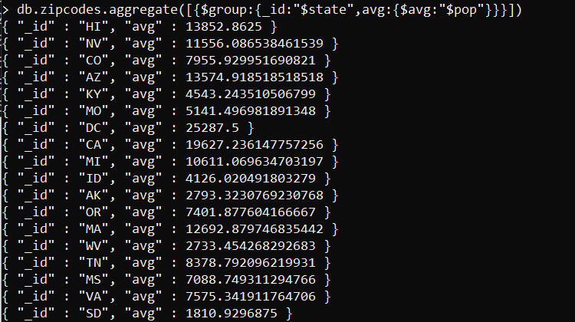

1. What are the top 3 states in terms of average city population?

* db.zipcodes.aggregate([{$group:{_id:"$state",avg:{$avg:"$pop"}}},{$sort:{avg:-1}},{$limit:3}])

